**NEW MEMBERS**

**THANKYOU FOR JOINING COMBERTON SPORTS & ARTS GYM !**

**HERE ARE THE INSTRUCTIONS TO ACTIVATE THE FITSENSE APP. IN CONJUNCTION WITH OUR GYM MEMBERSHIP**

Please find below instructions for members to sign into the FITSENSE APP:

> Download the ‘Fitsense app’ from either IOS Store or Google Play Store

> Open app

> Click MEMBER SIGN IN

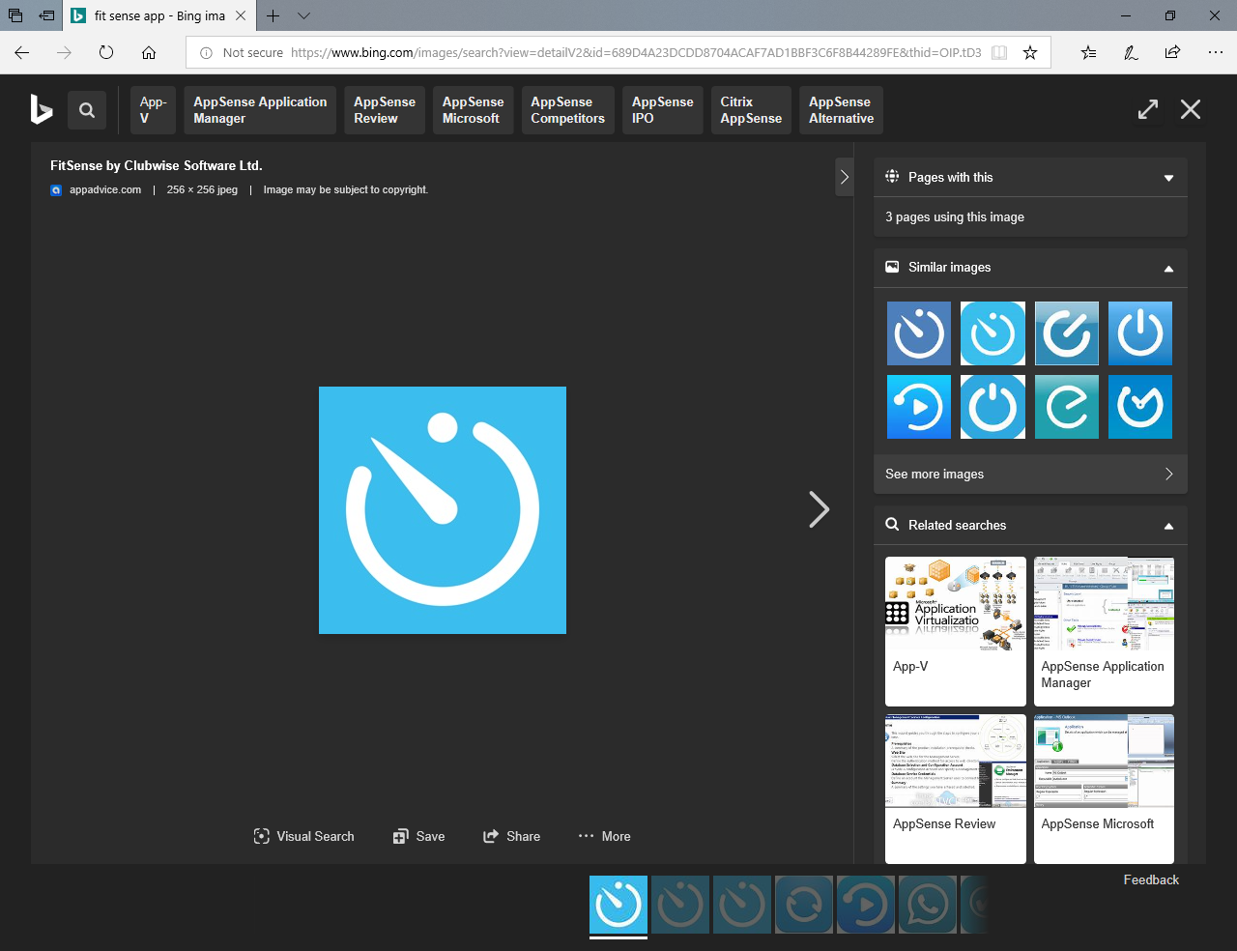

*Do NOT subscribe unless you want to pay for the app

> Click “Activate my Account” at top of page in BLUE

> Fill in required information:

                First name

                Surname

                Email

**THE FITSENSE APP**

CLUBWISE SOFTWARE

                Date of Birth

                Postcode

* These details must match what is in ClubWise or the activation will not work.

> Click “Activate Now”

> Pop up will show advising to check your email./SMS

> An email will be sent confirming the account has been activated and your password. (example email below)

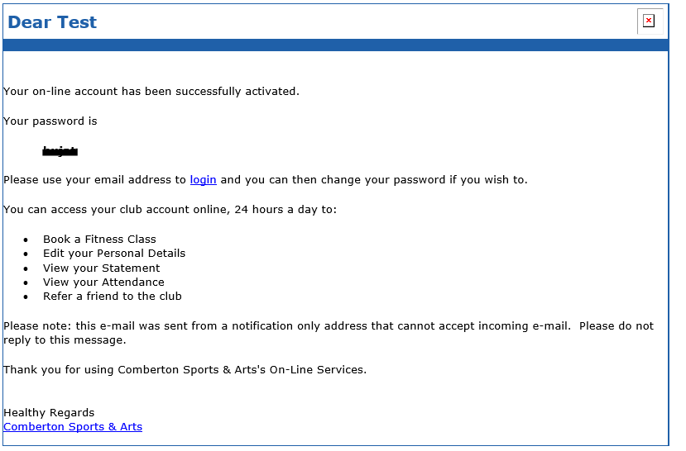

**WE LOOK FORWARD TO SEEING YOU SOON - ENJOY THE STUDIO CLASSES!**

**ANY PROBLEMS PLEASE CONTACT THE GYM FOR FURTHER ASSISTANCE ON**

[**COM-Enquiries@combertonvc.org**](mailto:COM-Enquiries@combertonvc.org) **or Tel: 01223 264444**